# Visual Hierarchy

## What is Visual Hierarchy?

“Visual hierarchy is the order in which a user processes information on a page; its function in user interface (UI) design is to allow users to understand information *easily*. By assigning different visual characteristics to sections of information (e.g., larger fonts for headings), a designer can influence what users will perceive as being further up in the hierarchy.” (interaction-design.org)

## Principles of Visual Hierarchy (interaction-design.org)

* **Size:** the larger the element, the more attention it will attract
* **Colour:** bright colours are more likely to draw attention over muted ones
* **Contrast:** dramatically contrasted colours will catch the eye easily
* **Alignment**: an element that breaks away from the alignment of others will attract more attention
* **Repetition**: repeating styles can give the impression that content is related
* **Proximity**: closely placed elements will also appear related
* **Whitespace**: more space around elements will attract the eye toward them
* **Texture** **and style**: richer textures will attract more attention than flat ones

## Importance of Visual Hierarchy

In order to guide our players to key in-game elements, a great level of attention has to be directed towards perfecting our games’ visual hierarchy. Player characters need to stand out, as well as any other important objects that might be added later on (e.g. turn timer).

## Known Constants

Despite rapid iteration and playtesting forming a very important role in perfecting visual hierarchy, there are a few known constants for our game that need to be established before designing the games’ main ‘in-match’ screen.

* Top-down perspective
  + Game is designed to be played in portrait mode, therefore a top-down perspective is best suited to ensure both players can clearly see the current game state at all times
* Both players need to be on the screen simultaneously
  + As a timing based ‘fighting’ game, both players need to be on screen at the same time to create a competitive atmosphere – the game needs to ***feel*** like a multiplayer, social experience, rather than two loosely connected single player experiences
* Considerations for additional mechanics that may need to be added
  + Potential examples include power-ups or a turn timer

## Developing a Visual Hierarchy



Figure 1- Establishing the core basics

In Figure 1, the player characters are represented by the circles on the top and bottom of the image. The circles are of large size to draw attention, however should probably be bigger. A bright triadic colour scheme is used to create a clear distinction between the first and second players against the background. The high contrast created between these colours also help to draw the player’s eye to their respective character. This is aided by the clear separation between the player characters – they are at opposite ends; closest to their respective player. A large gap is left between the player characters to leave room for their flying arms.

As we are aiming to eliminate the existence of an obnoxious timing bar and telegraph timing in more intelligent and natural ways, this concept currently lacks a power bar.

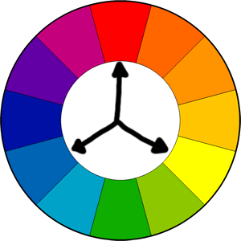

Figure 2- A visual representation of the triadic colour scheme used. Note how all colours are evenly spaced apart on the colour wheel.

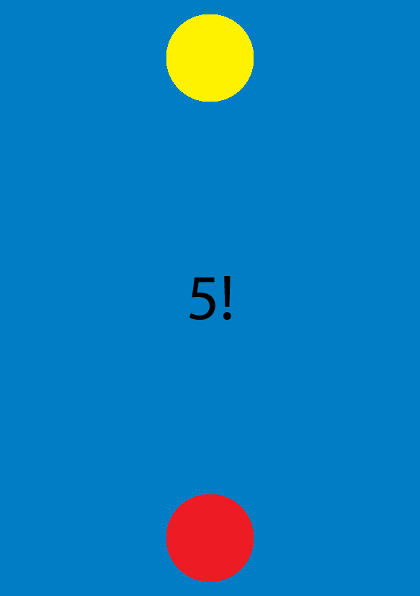

Figure 3- A minor second iteration, making the visuals perfectly symmetrical. Also experiments with a timer. May be a good idea to increase the size of the numbers as time runs closer to its end.

## Considerations Going Forwards

Given the early stage of design and current lack of playtesting required to tune and finalise game mechanics, it seems fruitless to currently commit more time towards cementing visual hierarchy beyond a core level.

Despite this, however, as we progress further through the Design, Playtest, Iterate loop we may have to pay considerations to additional design challenges that will inevitably effect visual hierarchy in the future. Examples of this include:

* Telegraphing to each player whose turn it currently is
* Telegraphing current progress
  + Who is winning?
* Theoretical new mechanics
* Finalised assets
  + Player characters
  + Background
  + In-game text
* Creation and Design of in-game menus

# Alternative User Experience Considerations

## Mobile Game Design Best Practices (packtpub.com)

“The first golden rule is that **the better the game interface is designed, the less it will be noticed by players**, as it allows users to navigate through the game in a way that feels natural and easy to grasp”.

The above details an instance whereby good UI design is entirely invisible – the player will only ever notice your UI design if it is bad and causes issues. The solution to this is to design the interface as simply as possible, ensuring that it “feels natural and easy to grasp”.

## Tips for Designing the Best UI

* Simplicity is key
  + The more straightforward the better. Everything needs to be clearly telegraphed and have an obvious and natural purpose.
  + Simple tap mechanic of our game needs to be kept as simple as possible
    - Player should be able to tap anywhere on the screen to interact with our game, avoid buttons at all costs!
      * E.g. Crossy Road – Single tap input, player can tap anywhere on the screen (as opposed to condescending ‘tap here’ button)
* Never make assumptions
  + The most prominent options must lead the player into the game
* Make considerations for the target platform
  + Device specifications, especially on Android, can vary enormously
    - Resolution and Pixels Per Inch (PPI/Pixel Density) frequently differs device to device
  + As stated by the brief, careful consideration has to be made in regards to scaling

## Screen Flow

“Once you come up with a list of the required options and game screens, create a flow chart to describe how the player navigates through the different screens and which options are available in each one.”

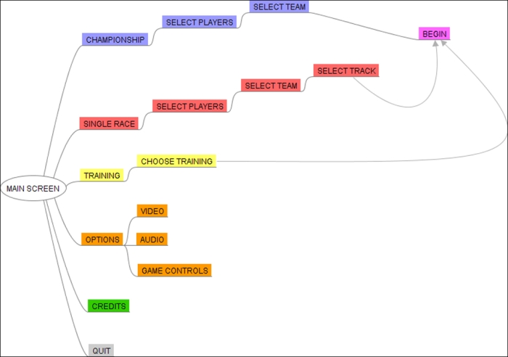

Figure 4 – An example of how this visual map may appear. Available at: <https://www.packtpub.com/sites/default/files/Article-Images/2984OT_07_08.jpg>

This flow map clearly shows the effectiveness of a game’s menu system and can be used to consolidate and remove unnecessary clutter.

## Functionality

What actions are required by the player? What info is required to express and telegraph how to input these actions?

“For every piece of information that you can deliver to the player, ask yourself if it is really necessary and where it should be displayed for optimal fruition”.

Useful hints:

* Keep number of buttons as low as possible
  + As previously stated, in our case we can perhaps avoid using them altogether
* Stick to one primary purpose for each game screen
* Refer to the screen flow to check the context for each game screen
* Split complex info into small chunks and/or multiple screens to avoid overburdening your players
  + In our case, the brief clearly states “the game should feature no more than one introductory info page as a tutorial. Everything else should be learned from the signs & feedback of the game”
  + Consequently, and due to the simplistic nature of our core game loop, there shouldn’t be any complex information to digest at all.